# 

# PFLAG Austin - Deidre Furr Essay Prize

The 2016-2017 Deidre Furr Essay Prize is sponsored by the Austin chapter of PFLAG [1].

This prize is awarded based on the quality of a 500 to 1000 word essay submitted on this year’s theme. Prizes will be awarded in spring of 2017. There will be a cash prize for 1st, 2nd and 3rd place of $500, $200 and $100 respectively.

***Rules and Requirements***

Applicants must be currently enrolled as a high school student in Georgetown ISD, Leander ISD, Round Rock ISD, Pflugerville ISD, or Austin ISD at the time of essay submission.

Email essays on the provided form to scholarships@pflagaustin.org

Minimum length: 500 words. Maximum length: 1000 words.

Deadline: March 1st, 2017.

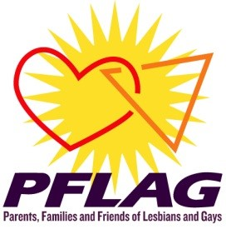

# PFLAG Austin - Deidre Furr Essay Prize

Essay contest submission form

**APPLICANT INFORMATION**

NAME: 

MAILING ADDRESS: 

CITY:  STATE:  ZIP: 

PHONE : ALTERNATE PHONE: 

BIRTHDATE (MM/DD/YY): EMAIL: 

The theme for the 2016-2017 essay contest is: "*…?*"

In 500 to 1000 words express your views on this topic. Paste your essay below this line and email this form to scholarships@pflagaustin.org

1. . PFLAG is the U.S.'s largest organization uniting people who are lesbian, gay, bisexual, transgender, and queer (LGBTQ) with families, friends, and allies, committed to advancing equality and full societal affirmation of LGBTQ people through its threefold mission of support, education, and advocacy.